EQUATION OF A LINE
Pearson Edexcel – Tuesday 19 May 2020 - Paper 1 (Non-Calculator) Higher Tier
1.
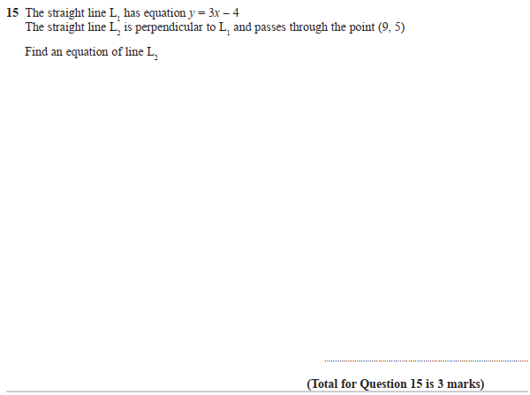

Pearson Edexcel - Thursday 6 June 2019 - Paper 2 (Calculator) Higher Tier
2.
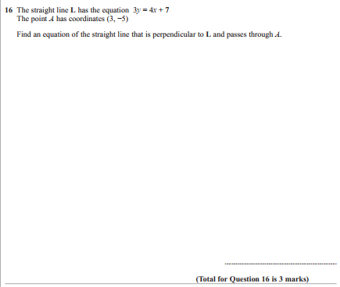

Pearson Edexcel - Thursday 7 June 2018 - Paper 2 (Calculator) Higher Tier
3.
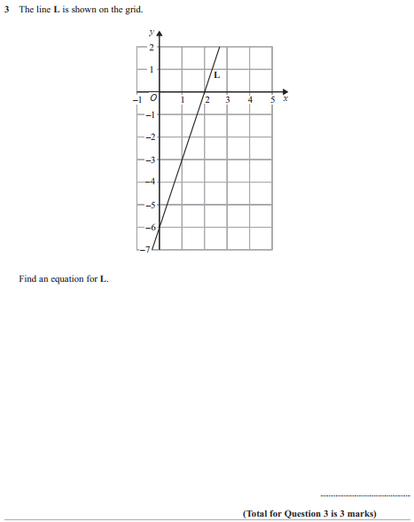

Pearson Edexcel - Thursday 2 November 2017 - Paper 1 (Non-Calculator) Higher Tier
4.
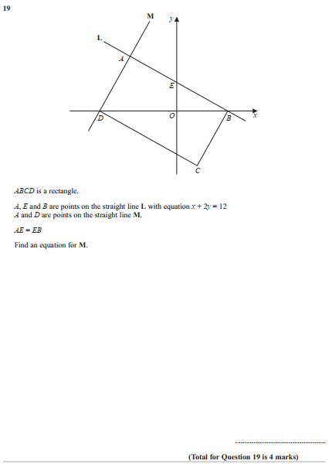

Pearson Edexcel - Specimen Papers Set 1 - Paper 1 (Non-Calculator) Higher Tier
5.
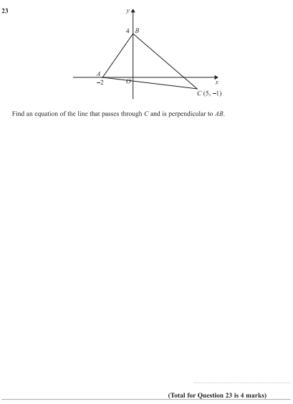

Pearson Edexcel - Specimen Papers Set 1 - Paper 2 (Calculator) Higher Tier
6.
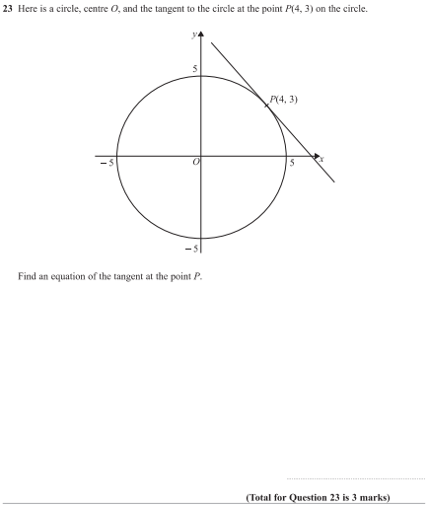

Pearson Edexcel - Specimen Papers Set 1 - Paper 3 (Calculator) Higher Tier
7.
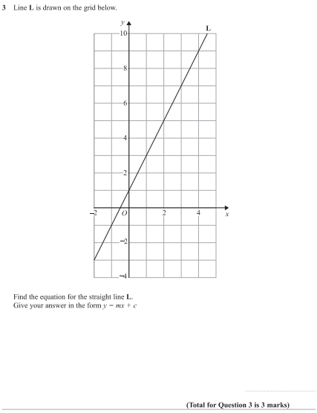

Pearson Edexcel - Sample Paper 1 - (Non-Calculator) Higher Tier
8.

Pearson Edexcel - Friday 6 November 2015 - Paper 2 (Calculator) Higher Tier
9.
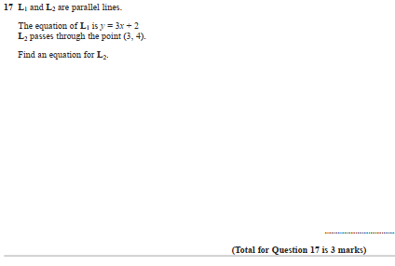

Pearson Edexcel - Monday 8 June 2015 - Paper 2 (Calculator) Higher Tier
10.
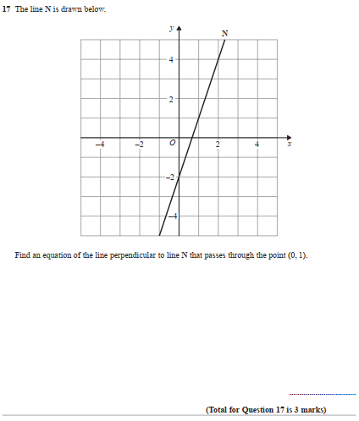

Pearson Edexcel - Monday 9 June 2014 - Paper 1 (Non-Calculator) Higher Tier
11.
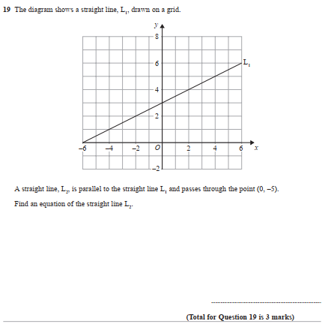

Pearson Edexcel - Monday 6 June 2011 - Paper 3 (Non-Calculator) Higher Tier
12.
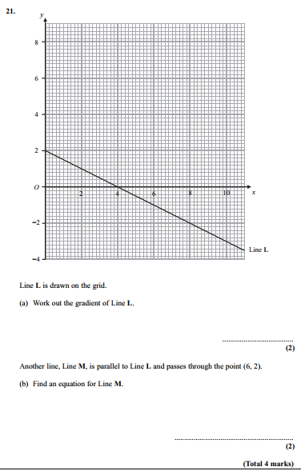

Pearson Edexcel - Monday 7 June 2010 - Paper 3 (Non-Calculator) Higher Tier
13.
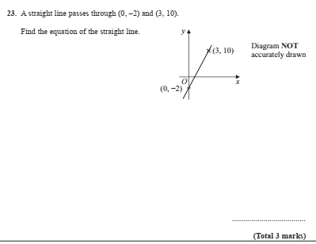
OCR GSCE – Tuesday 3 November 2020 – Paper 4 (Calculator) Higher Tier
14.
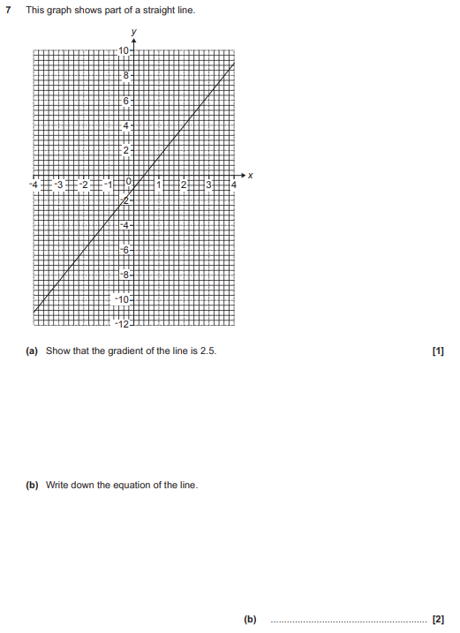

OCR GSCE – Tuesday 11 June 2019 – Paper 6 (Calculator) Higher Tier
15.
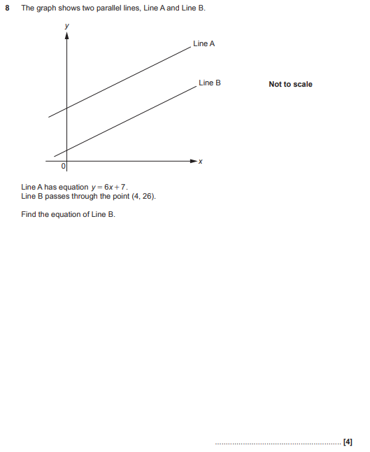

OCR GSCE – Tuesday 6 November 2018 – Paper 4 (Calculator) Higher Tier
16.
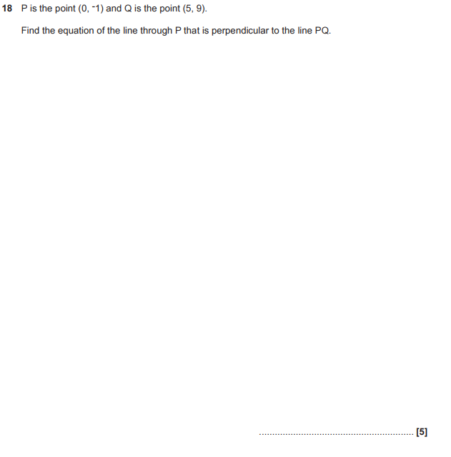

OCR GSCE – Thursday 7 June 2018 – Paper 5 (Non - Calculator) Higher Tier
17.
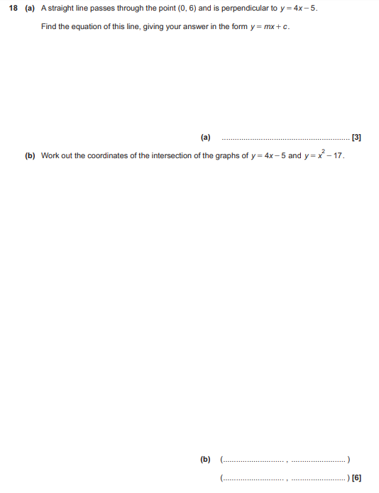

OCR GSCE – Tuesday 12 June 2018 – Paper 6 (Calculator) Higher Tier
18.
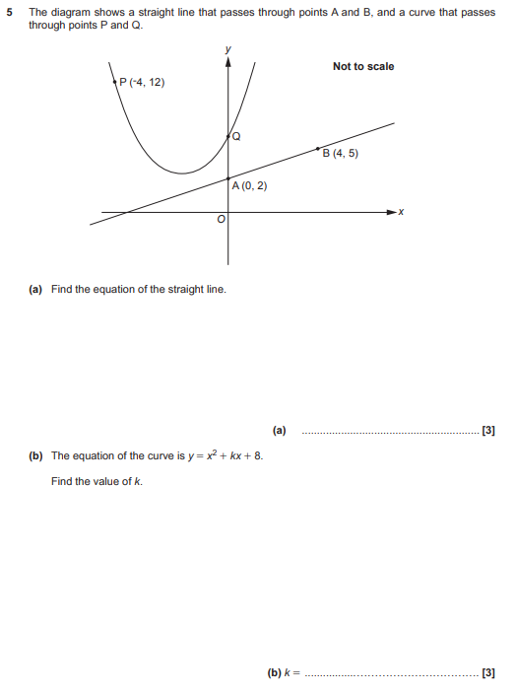

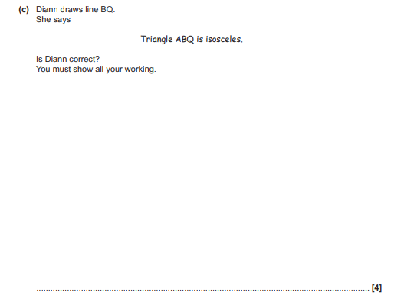
AQA GSCE – Thursday 8 June 2020 – Paper 3 (Calculator) Higher Tier
19.
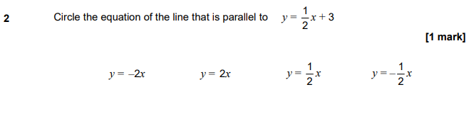
AQA GSCE – Thursday 8 June 2020 – Paper 3 (Calculator) Higher Tier
20.
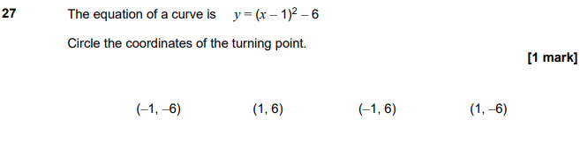
AQA GSCE – Thursday 6 June 2019 – Paper 2 (Calculator) Higher Tier
21.
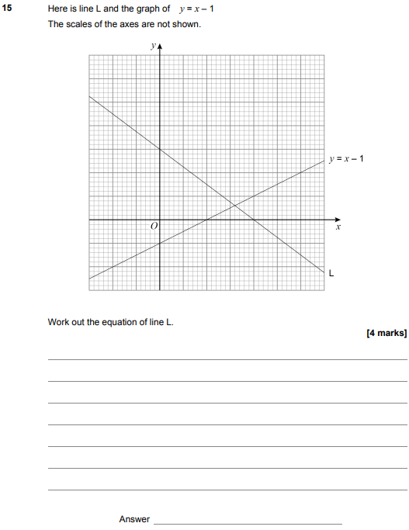

AQA GSCE – Tuesday 11 June 2019 – Paper 3 (Calculator) Higher Tier
22.
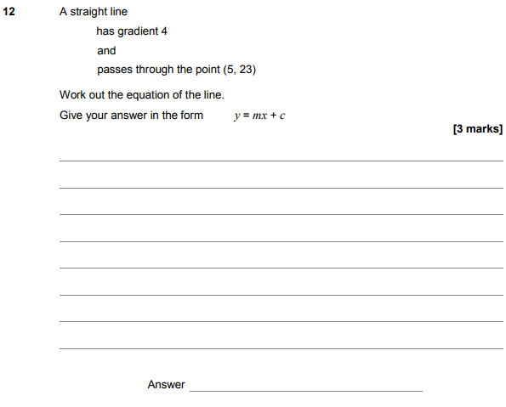

AQA GSCE – Tuesday 6 November 2018 – Paper 1 (Non - Calculator) Higher Tier
23.
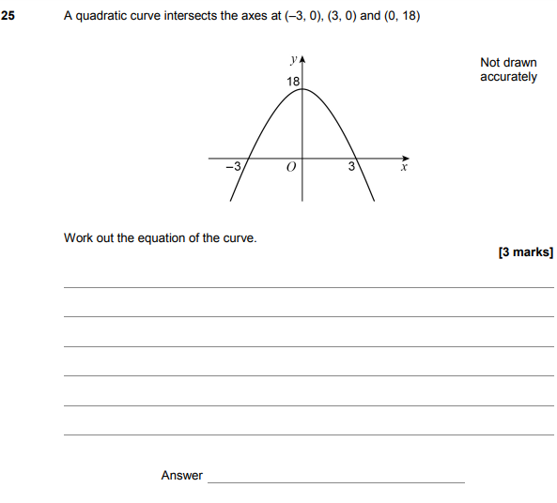

AQA GSCE – Monday 12 November 2018 – Paper 3 (Calculator) Higher Tier
24.
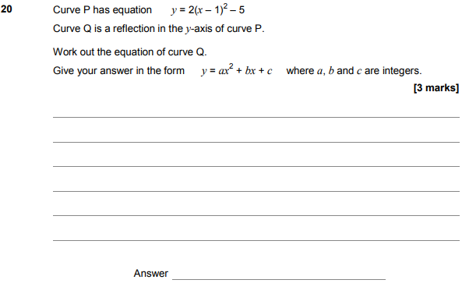

AQA GSCE – Monday 24 May 2018 – Paper 1 (Non - Calculator) Higher Tier
25.
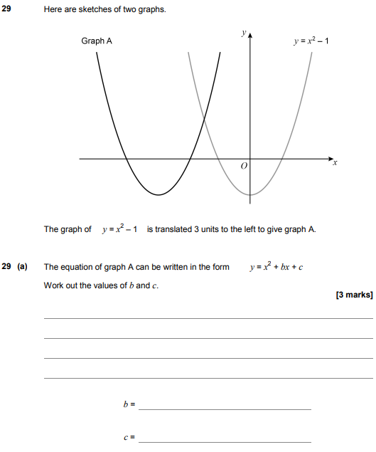
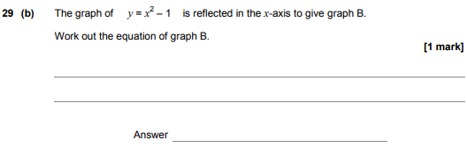

AQA GSCE – Thursday 7 June 2018 – Paper 2 (Calculator) Higher Tier
26.
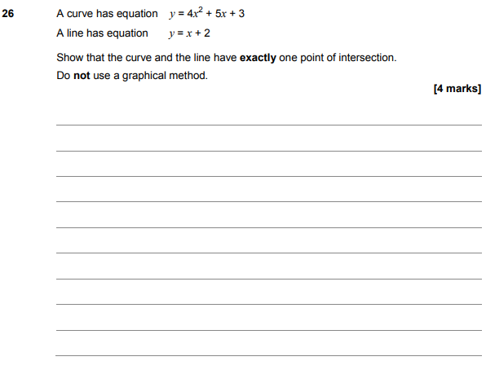

AQA GSCE – Tuesday 12 June 2018 – Paper 3 (Calculator) Higher Tier
27.
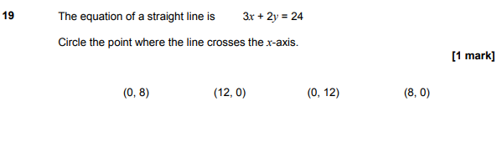
AQA GSCE – Wednesday 8 November 2017 – Paper 3 (Calculator) Higher Tier
28.
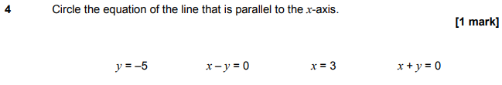 AQA GSCE – Wednesday 25 May 2017 – Paper 1 (Non - Calculator) Higher Tier
29.
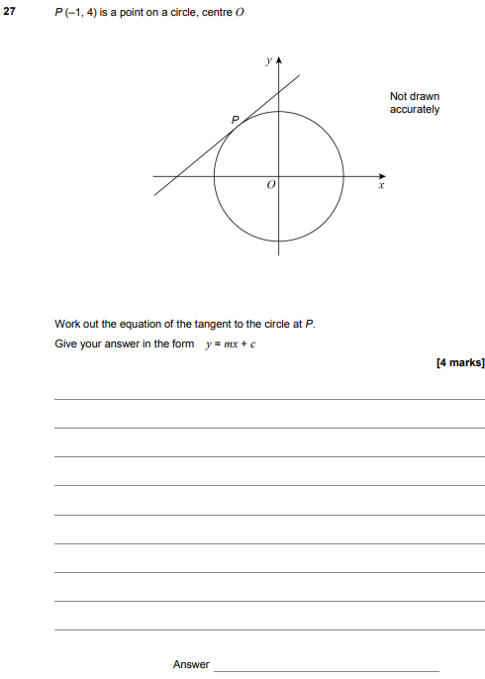

AQA GSCE – Sample Paper 2 (Calculator) Higher Tier
30.
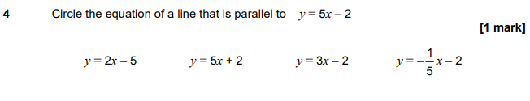
AQA GSCE – Sample Paper 3 (Calculator) Higher Tier
31.

